Lift simulation through MATLAB Simulink using Stateflow

Kristian Snel (2357399)  
Subject: Advanced Embedded Systems practical (AESP)  
Teacher: J. Jeedella.



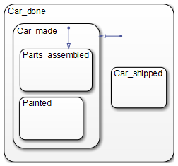

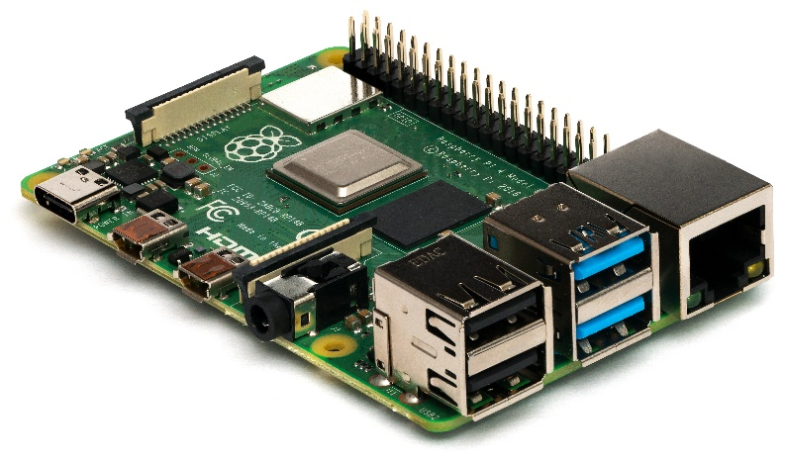

Latest version: 08-07-2020

Contents

Assignment 3

Software 3

StateFlow block 3

Simulation 4

Connecting to hardware 4

Sources: 7

# Assignment

This assignment has been given as a substitute assignment for the student to finish the AESP subject. The assignment requires the student to implement a Simulink Stateflow model of an Elevator Control System onto a Raspberry Pi. The model is an Elevator Control System (ECS), three buttons, three LEDs and a servo are used to emulate a elevator moving up and down depending on what buttons are pressed.

Originally the assignment comprised of implementing the Simulink Stateflow model on the Zybo Zynq-7000 Development board, although because of hardware failures the assignment has been shifted over to be implemented on Raspberry Pi.

# Software

MATLAB (2019b) is a computational analysis tool for engineers and scientist. MATLAB provides many tools and add-ons that allow the creations of graphics, graphs, calculations but also modeling and programming. Their support for Raspberry Pi through board support packages and code generation makes it excellent for the implementation of complex systems. Therefore, this assignment will be executed using MATLAB. Simulink is the system modeling add-on that is included with MATLAB. By modeling a system graphically instead of by programming. An engineer can quickly setup a complex system without the requirement of low-level embedded system programming. Stateflow is a modeling technique in Simulink that makes use of flow chart principles. By defining states and transitions the model can control many outputs from many inputs.

# StateFlow block

The controller is to be designed in Simulink StateFlow.

The system contains the following inputs and outputs and their respective names used in the StateFlow diagram.

|  |  |  |  |  |
| --- | --- | --- | --- | --- |
| I/O | Name | StateFlow Name | Values | Defenition |
| Output | LED1 | led1 | Boolean | 1 = ON, 0 = OFF |
| Output | LED2 | led2 | Boolean | 1 = ON, 0 = OFF |
| Output | LED3 | led3 | Boolean | 1 = ON, 0 = OFF |
| Input | Cabin&Floor Key 1 | button1 | Boolean | 1 = pressed, 0 = !pressed |
| Input | Cabin&Floor Key 2 | button2 | Boolean | 1 = pressed, 0 = !pressed |
| Input | Cabin&Floor Key 3 | button3 | Boolean | 1 = pressed, 0 = !pressed |
| Input | Proximity 1 | prox1 | Boolean | 1 = triggered, 0 = !trig |
| Input | Proximity 2 | prox2 | Boolean | 1 = triggered, 0 = !trig |
| Input | Proximity 3 | prox3 | Boolean | 1 = triggered, 0 = !trig |
| Input | Floor 1 | floor1 | Boolean | 1 = triggered, 0 = !trig |
| Input | Floor 1 | floor2 | Boolean | 1 = triggered, 0 = !trig |
| Input | Floor 1 | floor3 | Boolean | 1 = triggered, 0 = !trig |
| Output | M ON/OFF | motorPower | Boolean | 1 = ON, 0 = OFF |
| Output | DIRECTION | motorDir | Boolean | 0 = UP, 1 = DOWN |
| Output | SPEED | motorSpeed | ‘accelerate’,  ‘continuous’,  ‘decelerate’ | - |

Table : Parameter table.

# Simulation

To verify if our Stateflow model is functioning correctly we setup a simulation model with dashboard components. The verification model is shown in Figure 1. The three lamps represent the floor lights, the buttons represent both the buttons on each floor as well as the buttons in the elevator. The 4th lamp represents the elevator motor, yellow means going up while blue means going down.

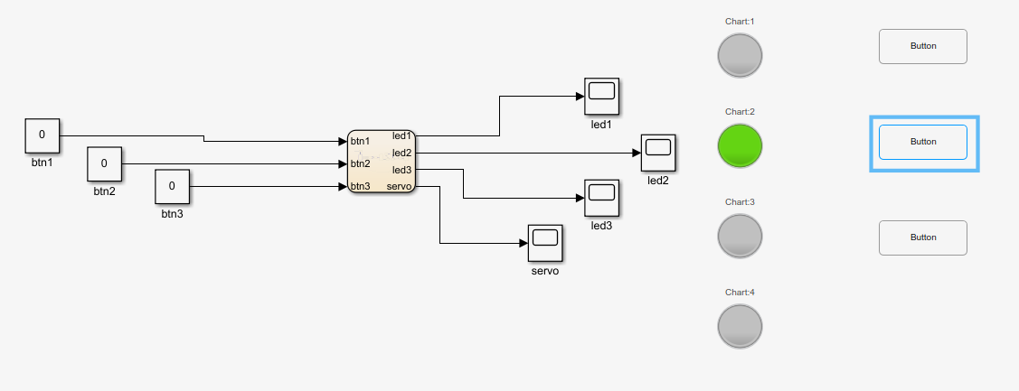

Figure 1: Simulink Stateflow verification model.

# Setting up hardware:

The Raspberry Pi with according hardware is setup as follows:

Figure : Raspberry Pi ECS hardware setup.

Three buttons allow the user to select the floor the elevator needs to go to. The three LEDs indicate the current position of the elevator. While the servo controls the position of the elevator by turning clockwise (up) or counterclockwise (down).

# Connecting to hardware

Configure hardware MATLAB 🡪 Add-Ons 🡪 Manage Add-Ons 🡪 Raspberry Pi Support from Simulink go to setup (cog icon) 🡪 Hardware setup

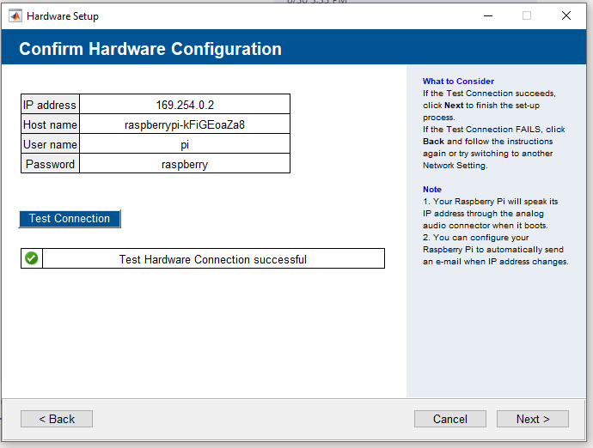

Figure : Hardware connection validation.

In Matlab type: $≫ raspi$ should start a connection. Close with $clear$.

Follow this tutorial for more information: <https://nl.mathworks.com/videos/getting-started-with-simulink-support-package-for-raspberry-pi-1558342725160.html>

# Sources:

<https://www.mathworks.com/discovery/state-chart.html>

Elevator Control System assignment:

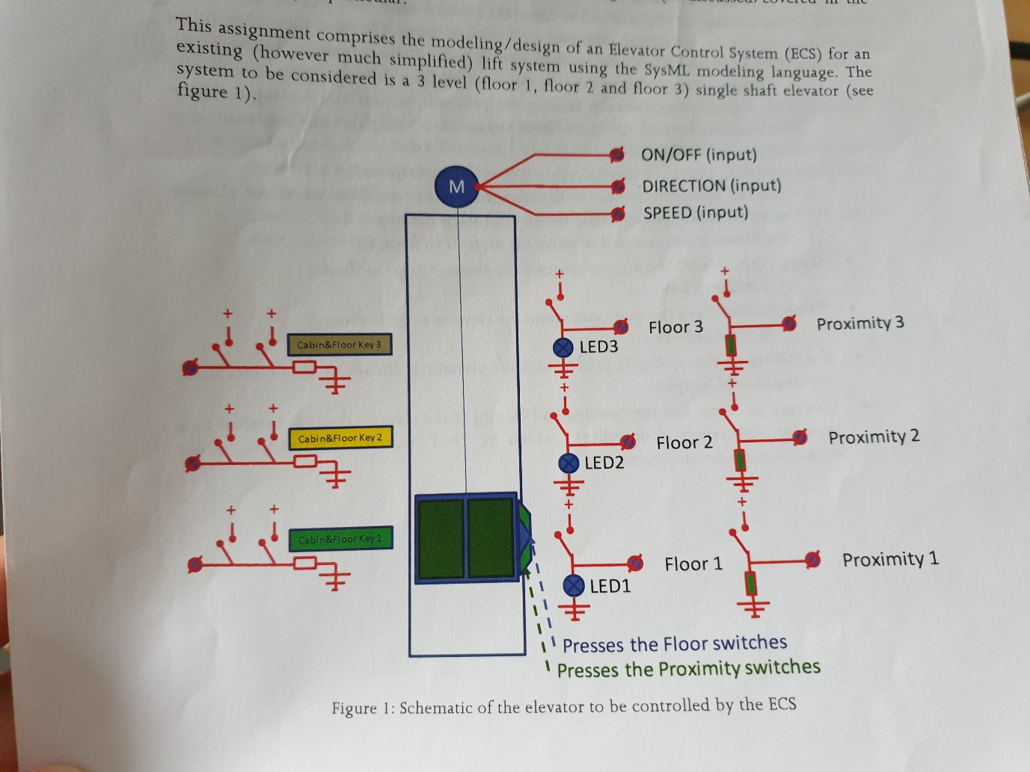

Figure 4: ECS assignment.

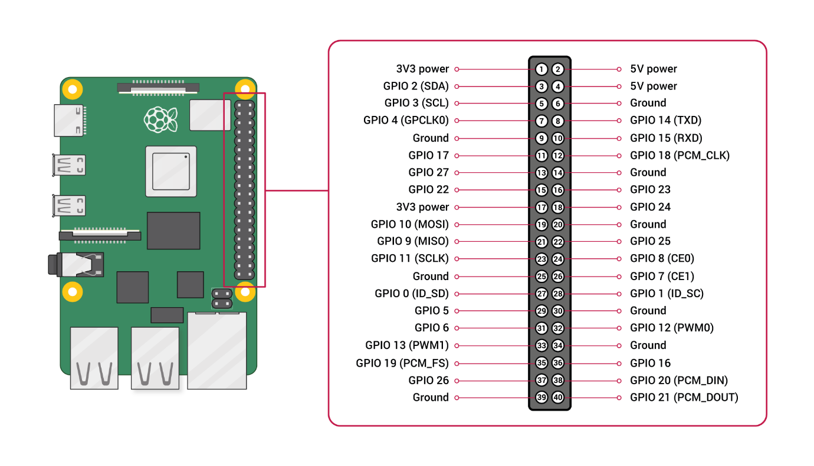

Figure 5: Raspberry Pi 4 pinout.